Mobile Phone Signal Detector

Region 1 comprises Europe, Africa, the former Soviet Union, Mongolia, and the Middle East west of the Persian Gulf, including Iraq.

Region 2 covers the Americas including Greenland, and some of the eastern Pacific Islands.

Region 3 contains most of non-FSU Asia east of and including Iran, and most of Oceania.

| EE Network Frequencies | | |
| --- | --- | --- |
| **Frequency** | **Frequency Band** | **Network** |
| 800MHz | Band 20 | 4G |
| 1800MHz | Band 3 | 2G & 4G |
| 2100MHz | Band 1 | 3G & 4G |
| 2600MHz | Band 7 | 4G |
| 3400MHz | Band 42 | 5G |

EE uses the 800MHz frequency, 1800MHz frequency, 2100MHz and 2600MHz frequency for 4G. The 800MHz frequency is long range, making it good for rural locations, but it can also penetrate walls, for strong indoor coverage. The 2600MHz frequency meanwhile is shorter range but deals well with congested areas like inner cities, and the 1800MHz and 2100MHz frequency is a middle ground. You can find in-depth details of those frequency bands in our [4G frequencies guide](https://www.4g.co.uk/4g-frequencies-uk-need-know/).

For 3G, EE uses 2100MHz, and for 2G is uses 1800MHz, though the network is becoming ever less dependent on these now that its 4G coverage is widespread.

EE also holds some spectrum in the 3.4GHz band, which comes into play for 5G.

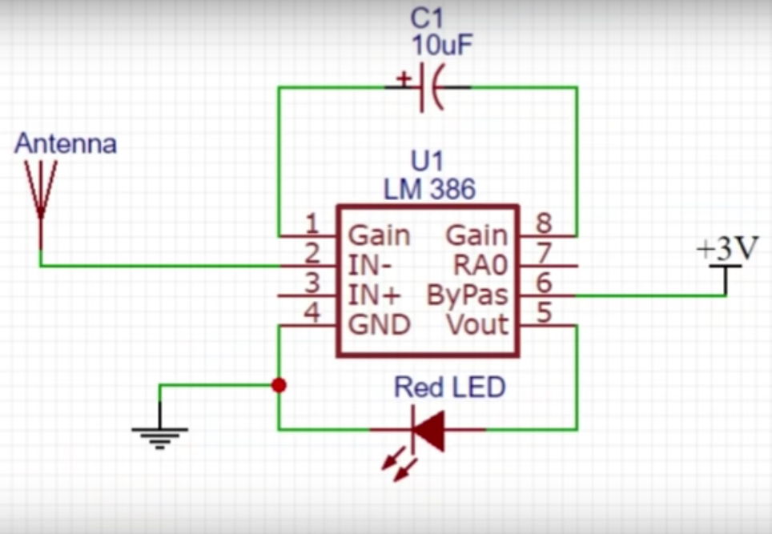

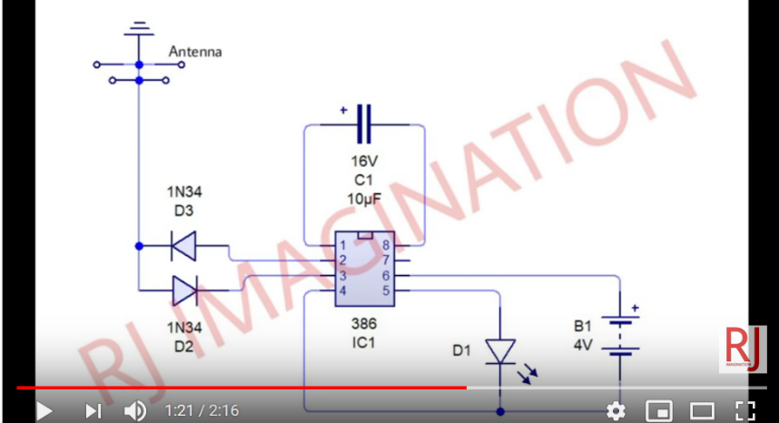

GAIN CONTROLTo make the LM386 a more versatile amplifier, two pins (1and 8) are provided for gain control. With pins 1 and 8 open the 1.35 kΩresistor sets the gain at 20 (26 dB). If a capacitor is put from pin 1 to 8, bypassing the 1.35 kΩresistor, the gain will go up to 200 (46 dB). If a resistor is placed in serieswith the capacitor, the gain can be set to any value from 20to 200. Gain control can also be done by capacitively cou-pling a resistor (or FET) from pin 1 to ground. GAIN CONTROLTo make the LM386 a more versatile amplifier, two pins (1and 8) are provided for gain control. With pins 1 and 8 openthe 1.35 kΩresistor sets the gain at 20 (26 dB). If a capacitoris put from pin 1 to 8, bypassing the 1.35 kΩresistor, thegain will go up to 200 (46 dB). If a resistor is placed in serieswith the capacitor, the gain can be set to any value from 20to 200. Gain control can also be done by capacitively cou-pling a resistor (or FET) from pin 1 to ground.

Antenna

Coiled copper wire, 1 mm dia

Use a screwdriver with a diameter of 3mm to wind copper wire around

Coils should not be touching each other

Youtube video <https://www.youtube.com/watch?v=5d2GJOVMWSs>