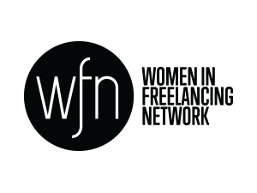

International Women’s Day Event
Tuesday 8th March, 6pm – 9.30pm
London

International Women’s Day – Tuesday 8th March 2016
International Women’s Day is a global celebration of women: their achievements in the economic, social and political sense. It also calls for women's rights, equality and awareness.
IPSE International Women’s Day event details:
This event will be hosted in partnership with The Talented Ladies Club, a successful resource of knowledge with practical, expert advice about starting a business, career change career and going freelance.
Title: Success stories of female freelances - inspiring a new generation.
Venue: St Ermins Hotel, 2 Caxton St, London SW1H 0QW
Objectives of event:
To celebrate women freelancers successes from a range of different backgrounds and industries
Bring together a group of diverse women to talk about their experiences as an independent professional
Inspire and empower our audience
Profile of audience:
Self employed/freelancing women from across a range of industries.
Event Format
This event will be hosted by Penny Haslam, Broadcaster, Journalist and Public Speaker. The format will be four one to one live interviews with Penny to explore how our interviewees reached their success.
We will then lead into an interactive panel session where we will address the themes raised during the interviews, give practical and empowering advice on achieving success and gain insight into overcoming the different challenges of working in different industries and turning it into success.
Timings:
6pm – Guests arrive and welcome drinks
6.45pm – Interviews with Penny Haslam (x 4)
7.15pm – Interactive panel session (x 4)
8.15pm – Networking drinks reception
Speakers:
Interviews
- Luan Wise, B2B Marketing Strategist
(In 2015 International Women’s Day LinkedIn UK recognised Luan as one of the top five female marketers)
- Kelly Gilmour-Grassam, Founder of Making you Content and winner of IPSE Aspire Award
- Female Engineer- TBC

- Freelance banker (TBC)
Panel
- MP representative
- Hannah Martin, Co-Founder and Editorial Director, Talented Ladies Club
- Female Journalist- TBC (suggestions from Caroline Morgan and James Gribben)
- Kate Taylor, life coach and NLP practitioner and Founder of Up Coaching (TBC)

