Global Warming and Climate Gasses (CO2 etc)

The “[No Climate Emergency](https://communities.theiet.org/discussions/viewtopic/807/24813?post_id=135203#p135203)” debate on the IET’s Savoy Club website has numerous views about why the climate science is wrong, though often it’s more a suggestion that the science is misdirected. This can be understood as being a consequence of the wide set of interacting factors in climate science being wider than the lay and interested observers grasp.

It’s worth delving into the available literature as to why certain features are of greater government concern when others point elsewhere.

The first point to note is that CO2 is the common product of burning carbon based fuels, which includes animal respiration. Before Humans started burning carbon based fuels the ‘natural environment’ was roughly stable over centuries and millennia with slow more geological processes dominating. CO2 fits within that stability because it’s lifetime in the atmosphere is of the order of a century. The natural environment included wood burning for the re-cycling of CO2.

Once we started mining and burning coal (and subsequently oil and gas) in significant quantities, we have generated significant extra CO2 into the atmosphere.

With the industrial age we have further developed our capabilities and now produce other atmosphere harming chemicals, at scale, which further exacerbates the issues of atmospheric balance, and allows the casual observer to point at other ‘root cause’ in a classic “[whataboutery](https://en.wikipedia.org/wiki/Whataboutism)” manner (a variant of the ‘tu quoque’ logical fallacy).

But why CO2? Firstly, there are other chemicals that matter, but not at the scale of CO2, so those other chemicals shouldn’t be forgotten (methane, Fluorides, etc.), especially by those that produce and use them, but are a lesser problem at global scale.

Excess CO2 is a problem because it is able to affect the absorption and emission of the sun’s energy, in the same way as a greenhouse can become warmer than the outside temperature in a non-equilibrium manner over the daily cycle. For CO2 that ‘daily solar cycle’ becomes a century long heating cycle.

The atmospheric effect does depend on the change in temperature with height, and that change in temperature affects the CO2 so that it’s filtering effect is enhance. On average more heat is kept in that is let out.

Let’s point to some articles:

[The Atmosphere: Getting a Handle on Carbon Dioxide](https://climate.nasa.gov/news/2915/the-atmosphere-getting-a-handle-on-carbon-dioxide/): October 9, 2019 Alan Buis, NASA's Jet Propulsion Laboratory.

“Carbon dioxide is a different animal, however. Once it’s added to the atmosphere, it hangs around, for a long time: between 300 to 1,000 years.”

[The greenhouse effect and carbon dioxide](https://rmets.onlinelibrary.wiley.com/doi/pdf/10.1002/wea.2072): Weather - April 2013, Vol. 68, No. 4 Wenyi Zhong and Joanna D. Haigh, ICL

“In the 1930s and 1940s Guy Stewart Callendar at Imperial College (London) revived the warming theory and by the 1970s it was generally accepted that global surface temperatures would increase as CO2 concentrations increased”

[CO2 Makes Up Just 0.04% of Earth's Atmosphere. Here's Why Its Impact Is So Massive](https://www.sciencealert.com/co2-is-only-a-tiny-part-of-our-atmosphere-but-it-has-a-huge-influence-here-s-why): Jason West, The Conversation, 16 Sep 2019

“The scientists who first identified carbon dioxide's importance for climate in the 1850s were also surprised by its influence. Working separately, John Tyndall in England and Eunice Foote in the United States found that carbon dioxide, water vapor and methane all absorbed heat, while more abundant gases did not.”

“During the Cold War, the absorption of infrared radiation by many different gases was studied extensively. The work was led by the US Air Force, which was developing heat-seeking missiles and needed to understand how to detect heat passing through air.”

[Absorption coefficient of carbon dioxide across atmospheric troposphere layer](https://www.ncbi.nlm.nih.gov/pmc/articles/PMC6174548/pdf/main.pdf)

“Fig. 1. Transmission of shortwave solar irradiation and longwave radiation from the Earth’s surface through atmosphere[22]. Greenhouse effect results from difference in down going solar radiation in red region and upgoing thermal radiation in blue region. Solar irradiation is absorbed, scattered and transmitted through the atmosphere and absorbed by the Earth’s surface. Irradiation from the Earth’s surface can be absorbed by carbon dioxide, water vapor and other emission gases in different bands of wave-length. Major amounts of oxygen gas and nitrogen gas are transparent to infrared radiation.”

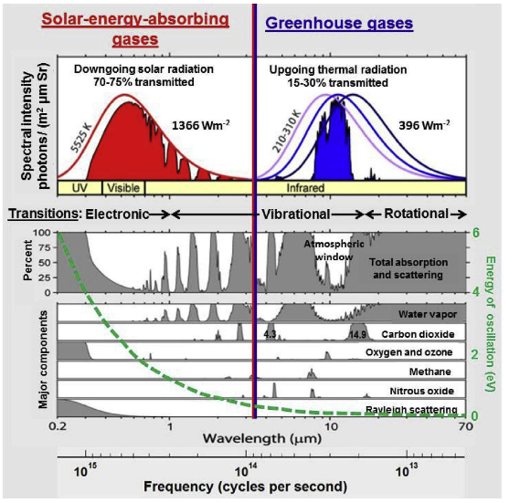

Other material

<https://en.wikipedia.org/wiki/Carbon_dioxide_in_Earth%27s_atmosphere>

<https://en.wikipedia.org/wiki/Infrared_window>

<https://en.wikipedia.org/wiki/Carbon_dioxide_in_Earth%27s_atmosphere>

[https://en.wikipedia.org/wiki/Schwarzschild's_equation_for_radiative_transfer#Origin_of_the_greenhouse](https://en.wikipedia.org/wiki/Schwarzschild's_equation_for_radiative_transfer#Origin_of_the_greenhouse_effect)

<https://www.esrl.noaa.gov/gmd/education/info_activities/pdfs/LA_whats_so_special_about_co2.pdf>

So, as mentioned in some of the articles, there can be a confusion /misunderstanding about what makes an equilibrium and exactly which parts have what equality. This leads to misdirerection.