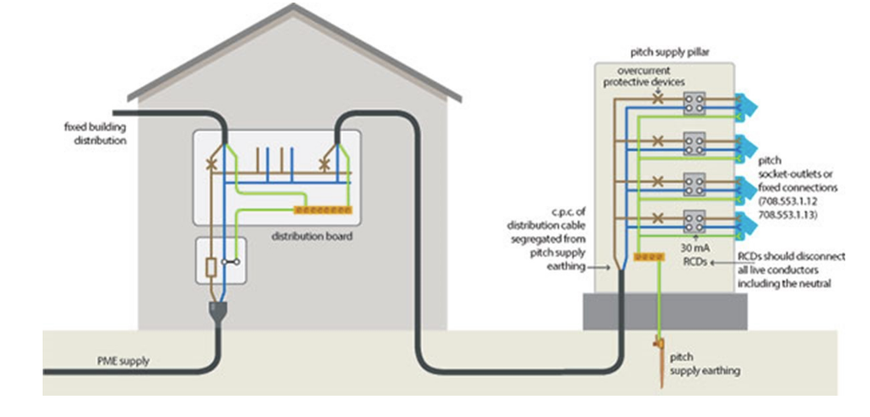

<https://electrical.theiet.org/wiring-matters/years/2016/61-summer-2016/electrical-installations-in-caravancamping-parks-caravans-and-motor-caravans/>