Events Sec: Angus Haston

1 Turbine House

Lintzford Co. Durham NE39 1NB

Mob: 07905-102865

 sugna@outlook.com

# MEETING AT WESTERHOPE METHODIST CHURCH HALL, NE5 5HA

## Wednesday 15th November 2023 at 12-noon

## BUFFET LUNCH followed by a talk on:

## The Impact of the Romans in the North East

**A talk given by Graeme Stobbs**

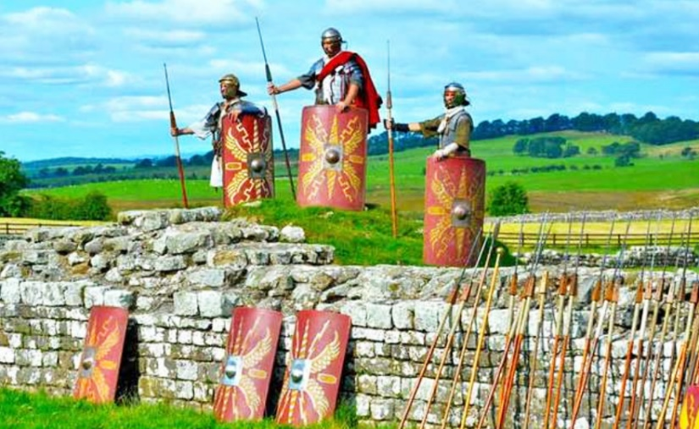

From the time that the Romans invaded Britain in 43 BCE, their army battled and soon established Roman rule over Britain, spreading their culture, laws, and language. Many battles were fought, including the uprising of the famous Queen Boudica.

The Romans brought many new things to Britain, including plants like nettles and animals like rabbits. They established towns and a new language (Latin). There hadn’t been written language up until this point, and Romans taught Britons in power to read, write and count. They built new buildings that were much more sophisticated than the roundhouses and huts many Britons lived in. They also built roads to allow for easier transportation of soldiers and goods.

Temples were built dedicated to Roman gods, until they eventually adopted Christianity and brought that over to Britain too - Christianity had been previously banned in Britain in the second century. However, in 313 CE, when Christianity had become more and more popular, Emperor Constantine declared that Christians were permitted to worship freely. This talk will cover the extended period from the invasion, through the following years of occupation, and beyond – the legacy.

The Speaker: Graeme Stobbs is an archaeologist who has worked for over 35 years on various sites, from prehistoric to post-medieval/industrial, across the north. His passion, however, is the Roman era, particularly Hadrian’s Wall (and its little cousin, the Antonine Wall in Scotland). Now semi-retired (a polite way of saying ‘now getting under the wife’s feet’), he undertakes archaeological consultancy work, leads tours of the Wall, and gives illustrated talks.

…

The cost for this lunch and talk is **£15.00** per head. If you would like to come along either:

* **Advise me by email that you are coming, giving the attendee’s name(s) and concurrently pay the required amount by bank transfer (using the internet).**

**Or**

## Detach and post the completed application form (on page 2) addressed to Patrick Pratt, together with your cheque.

**Please email your reply, or return the form, on or before: Saturday 4th November 2023**

**Our Bank details are: Northumbria IET RMS Account, Sort Code: 20-59-59,**

**Account Number: 40093300. Payment Reference: Your initial(s) and Surname (e.g. A N**

**Smith) followed by the date of the Talk (given as 6 digits - e.g. 151123).**

**Application Form**

- - - - - - - - - - - - - - - - - - - - - - - - - - - - - - - - - - - - - - - - - - - - - - - - - - - - - - - - - - - - - - - - - - - - - - - - -

**IET RMS MEETING AT WESTERHOPE**

**Wednesday 15th November 2023 at 12 noon**

**BUFFET LUNCH followed by a talk on:**

**The Impact of the Romans in the North East**

## A talk given by Graeme Stobbs

* Please send a cheque made payable to **Northumbria IET RMS** to:

**Patrick Pratt, 42 Earnshaw Way, Whitley Bay, Tyne & Wear, NE25 9UN**

* **Members without email addresses, please enclose a stamped addressed envelope.**
* A list of those attending, travel instructions and admission tickets (when required) will be sent to members by email unless a stamped addressed envelope has been enclosed with the application.

I wish to apply for place(s) for the above event. Tick here if travel instructions are required.

**A cheque for £_ is enclosed (£15.00 per person)**

**Name(s)_ Tel No.: _ __ _**

If you are not a member of IET RMS, please add your email address:

*The speaker’s comments:*

*No written language*

*Iron age inhabitants prior to the Romans*

*Just a warning in advance though - this equates to half a millenia, so while I'll be giving a lot of information we'll not be going too in-depth about the archaeology and subsequent exploration of each and every site. Also, after doing talks for over 30 years I often find that sometimes audiences are disappointed not to be hearing about the social history of the Romans in the north (it was a military occupation throughout) and about the Iron Age inhabitants prior to the arrival of the Roman army. Of the latter, whilst a 'Celtic' language existed it was never written down in any form, hence these people have no 'voice'.*

The Roman occupancy in Britain, spanning roughly from 43 to 410 AD, left an indelible mark on our island's history.

Initially launched as a military campaign by Emperor Claudius in 43 AD, the Romans gradually established control over the region. They brought advanced engineering, building roads, aqueducts, and structures like Hadrian's Wall, connecting disparate parts of the land and enabling efficient transportation and communication. This infrastructure laid the groundwork for modern urban development. New agricultural techniques were introduced, fostering a shift in farming practices and increasing food production.

The Roman presence brought about a fusion of cultures, as local traditions intertwined with Roman customs, language, and governance.

The period was not without its conflicts, with resistance from indigenous tribes and fluctuating power dynamics. However, Roman governance brought stability, leading to the growth of towns and trade.

While the Roman withdrawal in 410 AD marked the end of their direct rule, their legacy endured. The centuries of Roman occupancy laid the foundation for Britain's future development; the legal, administrative, and linguistic remnants of Roman rule persisted in the fabric of British society.