Events Sec: Angus Haston

1 Turbine House

Lintzford Co. Durham NE39 1NB

Mob: 07905-102865

 sugna@outlook.com

# MEETING AT WESTERHOPE METHODIST CHURCH HALL, NE5 5HA

## Wednesday 18th October 2023 at 12-noon

## Extraordinary General Meeting (EGM) to review amendments to our Constitution;

## Fork and knifeFollowed by our usual excellent BUFFET LUNCH; followed by a talk on:

## The North East Land Sea and Air Museum

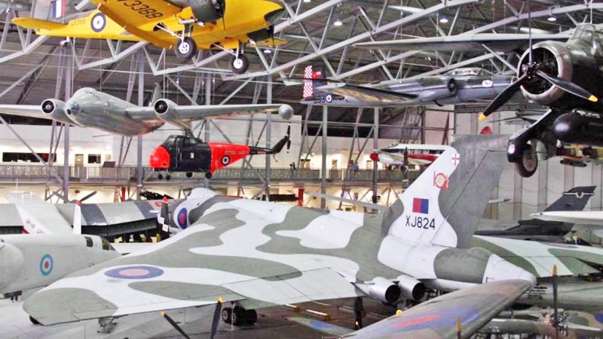This entertaining and informative talk will take us through the collections of the North East Land Sea & Air Museum (NELSAM).

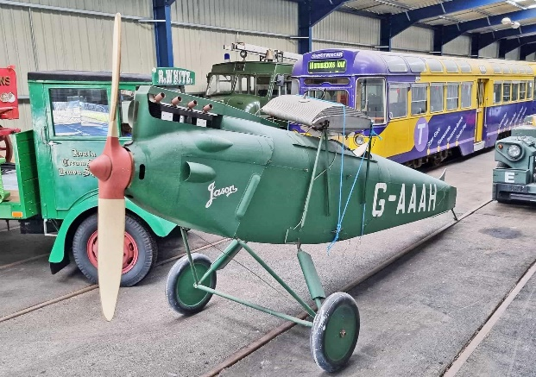The museum sits on the former RAF Usworth and Sunderland airport site and comprises the former Aircraft Museum (NEAM), military vehicles collection. The North East Electric Traction Trust (NEETT) is also based on the site. Amongst the varied and unique exhibits is a cold war Avro Vulcan B2 Bomber, which flew into the former airport to become the first Vulcan to go into a private collection.

The museum has the largest aviation collection between Yorkshire and Scotland and houses over 30 aircraft, a wide collection of aero engines, and other items such as weaponry.

There is also a large military collection, from tracked armoured vehicles to transport trucks, vehicles and other historical exhibits.

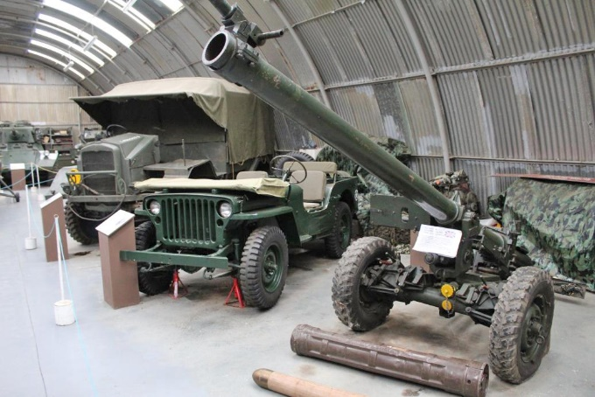

The Speaker, Ian McLaren, is the Sec of the organization as well as one of the museum volunteers and has a wealth of knowledge of the collections.

The cost for this lunch and talk is **£15.00** per head. If you would like to come along either:

* **Advise me by email that you are coming, giving the attendee’s name(s) and concurrently pay the required amount by bank transfer (using the internet).**

**Or**

## Detach and post the completed application form (below) to Patrick Pratt together with your cheque.

**Please email your reply or return the form on or before: Saturday 7th October 2023**

**Our Bank details are: Northumbria IET RMS Account, Sort Code: 20-59-59,**

**Account Number: 40093300. Payment Reference: Your initial(s) and Surname (e.g. A N**

**Smith) followed by the date of the Talk (given as 6 digits - e.g. 181023).**

**Application Form**

- - - - - - - - - - - - - - - - - - - - - - - - - - - - - - - - - - - - - - - - - - - - - - - - - - - - - - - - - - - - - - - - - - - - - - - - -

**IET RMS MEETING AT WESTERHOPE**

**Wednesday 18th October 2023 at 12 noon**

**BUFFET LUNCH followed by a talk on:**

**North East Land Sea and Air Museum**

* Please send a cheque made payable to **Northumbria IET RMS** to:

**Patrick Pratt, 42 Earnshaw Way, Whitley Bay, Tyne & Wear, NE25 9UN**

* **Members without email addresses, please enclose a stamped addressed envelope.**
* A list of those attending will be sent to members by email unless a stamped addressed envelope has been enclosed with the application.

I wish to apply for place(s) for the above event. Tick here if travel instructions are required.

**A cheque for £_ is enclosed (£15.00 per person)**

**Name(s)_ Tel No.: _ __ _**

If you are not a member of IET RMS, please add your email address: