Engineering Centre of Excellence
Leconfield Industrial Estate
Cleator Moor

At Sellafield Ltd. we want everyone to feel welcome and remain safe in all our locations.
People are encouraged to request any specific reasonable adjustments and accessibility requirements they need ahead of attending any of our venues. To make this easier this document provides information about accessing the Sellafield Ltd Engineering Centre of Excellence, on the Leconfield Industrial Estate at Cleator Moor.
This is an older building which Sellafield Ltd. do not own, so there are certain aspects that do not meet our expected accessibility standards. We have provided information below so that people are aware of these limitations and other issues they may need to be aware of when deciding to attend the Sellafield Ltd Engineering Centre of Excellence.
How To Find Us
The post code for the Sellafield Ltd Engineering Centre of Excellence is CA25 5QB (for those using Google Maps/sat nav to find the building), and you can contact the reception desk on 01946 458825 if you have questions about accessibility that are not addressed here.
Limited Street parking is available, please park adjacent to the pavement only on the side of Unit 6. Strictly No parking is permitted on the opposite side of the road as it causes the road and footpath to become impassable to pedestrians, particularly those with pushchairs traveling to and from the local Nursery. Also restricting access for other Vehicles, especially vans and lorries, supporting other businesses on the estate.
The main car parking area for the facility is located a short walk away (shown on diagram) which can be found by following the main access road past Unit 6, following it round to the right and the car park is directly in front of you on the right at the end of the road. There is also an overspill next on the left before the nursery but please note, DO NOT park in the first 2 bays located directly in front of the nursery, these are for nursery use only.
There are 2 designated disabled parking bays at the facility, located by the loading bays. If these are full, please park at the front of the facility.
Please note there is 5mph site speed limit on the Leconfield estate.
Overspill car park do not park in parent and child places, or first 2 rows nearest front door of nursery.

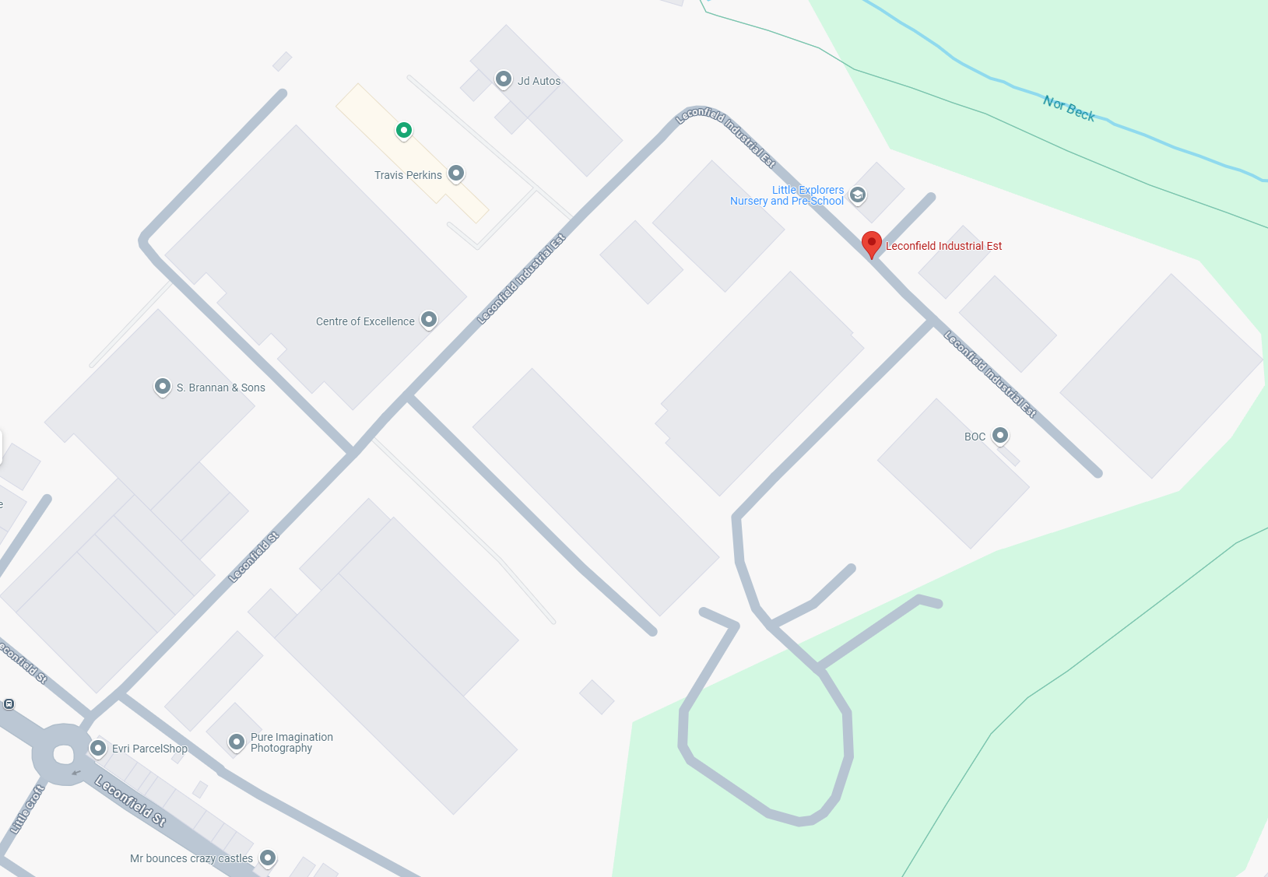

No parking on this side of the road, on the grass or junction

Designated Parking Area Large car park

Blue badge holders - If disabled parking is required, please inform your escort or Works Control Office 01946 458825 before attending.

Motorcycles - Motorcycle spaces are available the same as cars.

Visitors – Visitor parking is available as per diagram. Parking at Leconfield is at your own risk.

By Bus - There are several bus services that currently run to and from Whitehaven that drop off at a bus stop within walking distance of Unit 6 (situated on the main road).
Accessing the Building
If you do not have a resident pass to access the building, you will need to sign in at the reception desk as a visitor and be issued a visitors’ pass, so allow for time to do this.
For visitors who do not have Sellafield security clearance (P4), it will be the responsibility of their escort/sponsor to obtain proof of identity. The escort should also ensure that the visitor brings with them a photo ID driving license or passport as proof. The escort must sign the visitor in and ensure they are always escorted whilst in the building, they will be issued an escorted (red) building pass.
There are steps leading to the building, and the main entrance doors are not power assisted. There is also a flat walkway that leads from a small parking area to the north side of the building, it leads to the same entrance.
Sellafield Ltd operates UAVs (drones) from the concrete pad opposite the main entrance. If operations are underway during your arrival or departure from the facility, please do not distract the pilot and avoid the immediate flight area.
Clothing Requirements
This is a working Rig Hall therefore the clothing requirements must be appropriate i.e., fully enclosed shoe, legs covered (as best as reasonably practicable).
Appropriate footwear to be worn when accessing bays on the Rig Hall according to local bay rules - shoes/ boots with toe cap, unless otherwise risk assessed out to provide protection during various activities such as moving equipment/ furniture, moving/ accepting deliveries and the work being carried out in the workshop by various workspaces.

Clothing needs to protect against hazards on site. The main reason for protecting the lower legs is to help guard against cuts, grazes, splinters, chemical/ product usage etc in a workshop environment where any skin damage can lead to infection and where there are various work faces, interactions, events, demos etc.
Welfare Information
There are toilet facilities throughout the building, including accessible toilets in the main rig hall area.
Showers are provided in the rig hall area of the facility for residents to utilise. These showers are gender neutral, and feature three privacy cubicles for both showering and changing. There is a private shower located in the disabled toilet, for access please see work control office.
Lockers are available in the changeroom if required.
There is a dining area which includes two fridges, hot water boiler, a sink and two microwaves.
General Information
The doors within the Sellafield Ltd Engineering Centre of Excellence are not power-assisted, and only some are two-way. If you need assistance, please either let someone at Reception or a colleague know, and they will arrange for someone to help you.
The main corridor leading between the entrance and the offices, kitchen and workshop areas is narrow, though there are no internal steps or stairs to navigate.
There are various seating options within the open-plan office area which can be adjusted for anyone with mobility aids. (Where possible please notify the facility in advance).
The fire muster point is in the small car park, North of the building, near loading bay.
Sensory Information
The rig hall area has multiple open-top bays, features a range of equipment, and has large wall-mounted heaters throughout. This results in the noise level being variable, due to the bays being used by different teams at different times.
This can result in both prolonged loud noises (ear defenders are provided and mandatory once the 86-98dB(A) threshold has been reached) and layers of multiple different noises that may affect people with audiological sensory differences and/or hearing loss. Individuals are encouraged to bring their own noise reduction equipment if they have it, or standard ear defenders can be loaned on request.
The open-plan office area has white lighting and white walls, which can be too bright for individuals with visual sensory differences, so individuals may want to bring their own protective eyewear to reduce this.
While there is no loud equipment in the open-plan office area, there can be times when the noise level becomes more layered and complicated (due to normal day-to-day office activities and usage), so individuals with audiological sensory differences, hearing loss, or differences in attention regulation may wish to bring their own noise reduction equipment if they have it, or standard ear defenders can be loaned on request.
The other offices’ occupancy ranges from 2 to 4 persons per room. Meeting Pods are available in the street, occupancy is 4 maximums, no eating allowed and closed cups apply for all drinks. Can be prebooked for sensory requirement.
If you have any further questions about this, or suggestions for improvements, please contact steven.j.hodgson1@sellafieldsites.com.
You can also get in touch with the D&I Team at D&I.Team@sellafieldsites.com.

