Pigs, Small Fish and Hitler’s Beast

19th February 2026- 10.30 for 11.00 a.m.
at The Crooklands, Cumbria, LA7 7NW https://www.crooklands.com/

Speaker: Commander Bernard Thompson RN (Ret’d)

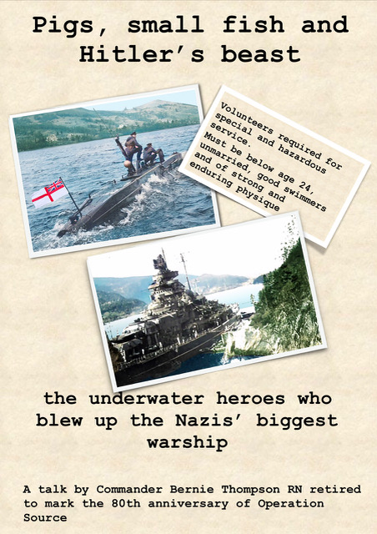

The story of Operation Source, the attack by X-craft midget submarines on the battleship Tirpitz, including lots of details of mini-sub design and characteristics, VC citations and a gripping sea story.

Please send your application by 12th February 2026 to:

Mike Bell, 52 South Park, Lytham, Lancs FY8 4QQ
M_bell_lytham@hotmal.com

Applications will be confirmed by email or post.Any queries to Mike on 07870 666917

BOOKING FORM OVERLEAF

BOOKING FORM

Please note we are transitioning to electronic banking and would prefer, if you can, bookings by email and payment by Bank Transfer. Cheques still acceptable!

Please reserve……...... places for the talk & lunch/talk only (please delete as applicable) on 19th February 2026 - 10.30 for 11.00 a.m. at Crooklands Hotel.

The optional3 course lunch is £30 per person. (The talk is free.)

I have paid ……. by (please delete option 1 or 2 belowas applicable):

- BACS to Business Current Account: ‘Friends of IET Lancs & Cumbria’. Account number: 20812353; Sort code: 01-00-61; Reference – Your surname and date of event. I attach a receipt for my electronic payment.
or
- I enclose a cheque, payable to ‘Friends of the IET, Lancs & Cumbria’

Please give forenames and surnames of all those applied for, and any special dietary requirements.

Name(s)………………………………………………………………………………………………………………………………………………………………………………………………………………………………………………………………………………………………………………………………………………………...……………………………………………………………………………………….….

Contact Phone no...............................

Please give email address,or an address we can use to send confirmation of your booking.

…………………………………………………………………………………………………………….

Programme for 2026
Next meeting
Titanic – Seaman’s perspective
10.30 for 11.00am 14th May 2026
Glendower Hotel, Lytham St Annes

