Pooley Bridge Replacement

Eric Wright Civil Engineering Ltd

23rd October - 10.30 for 11.00 a.m.
at The Crooklands, Cumbria, LA7 7NW https://www.crooklands.com/

Speaker: Antony Mulligan, Contracts Manager, Eric Wright Civil Engineering Ltd

Pooley Bridge is at the northern end of Lake Ullswater on the River Eamont which was crossed by a 250 year old stone bridge - until that was destroyed in the floods of Storm Desmond in 2015. This has now been replaced by a new bridge which was constructed on the river bank before being craned into place and was opened in 2020. The new stainless steel road bridge is the first structure of its kind in the country and cost £7M.

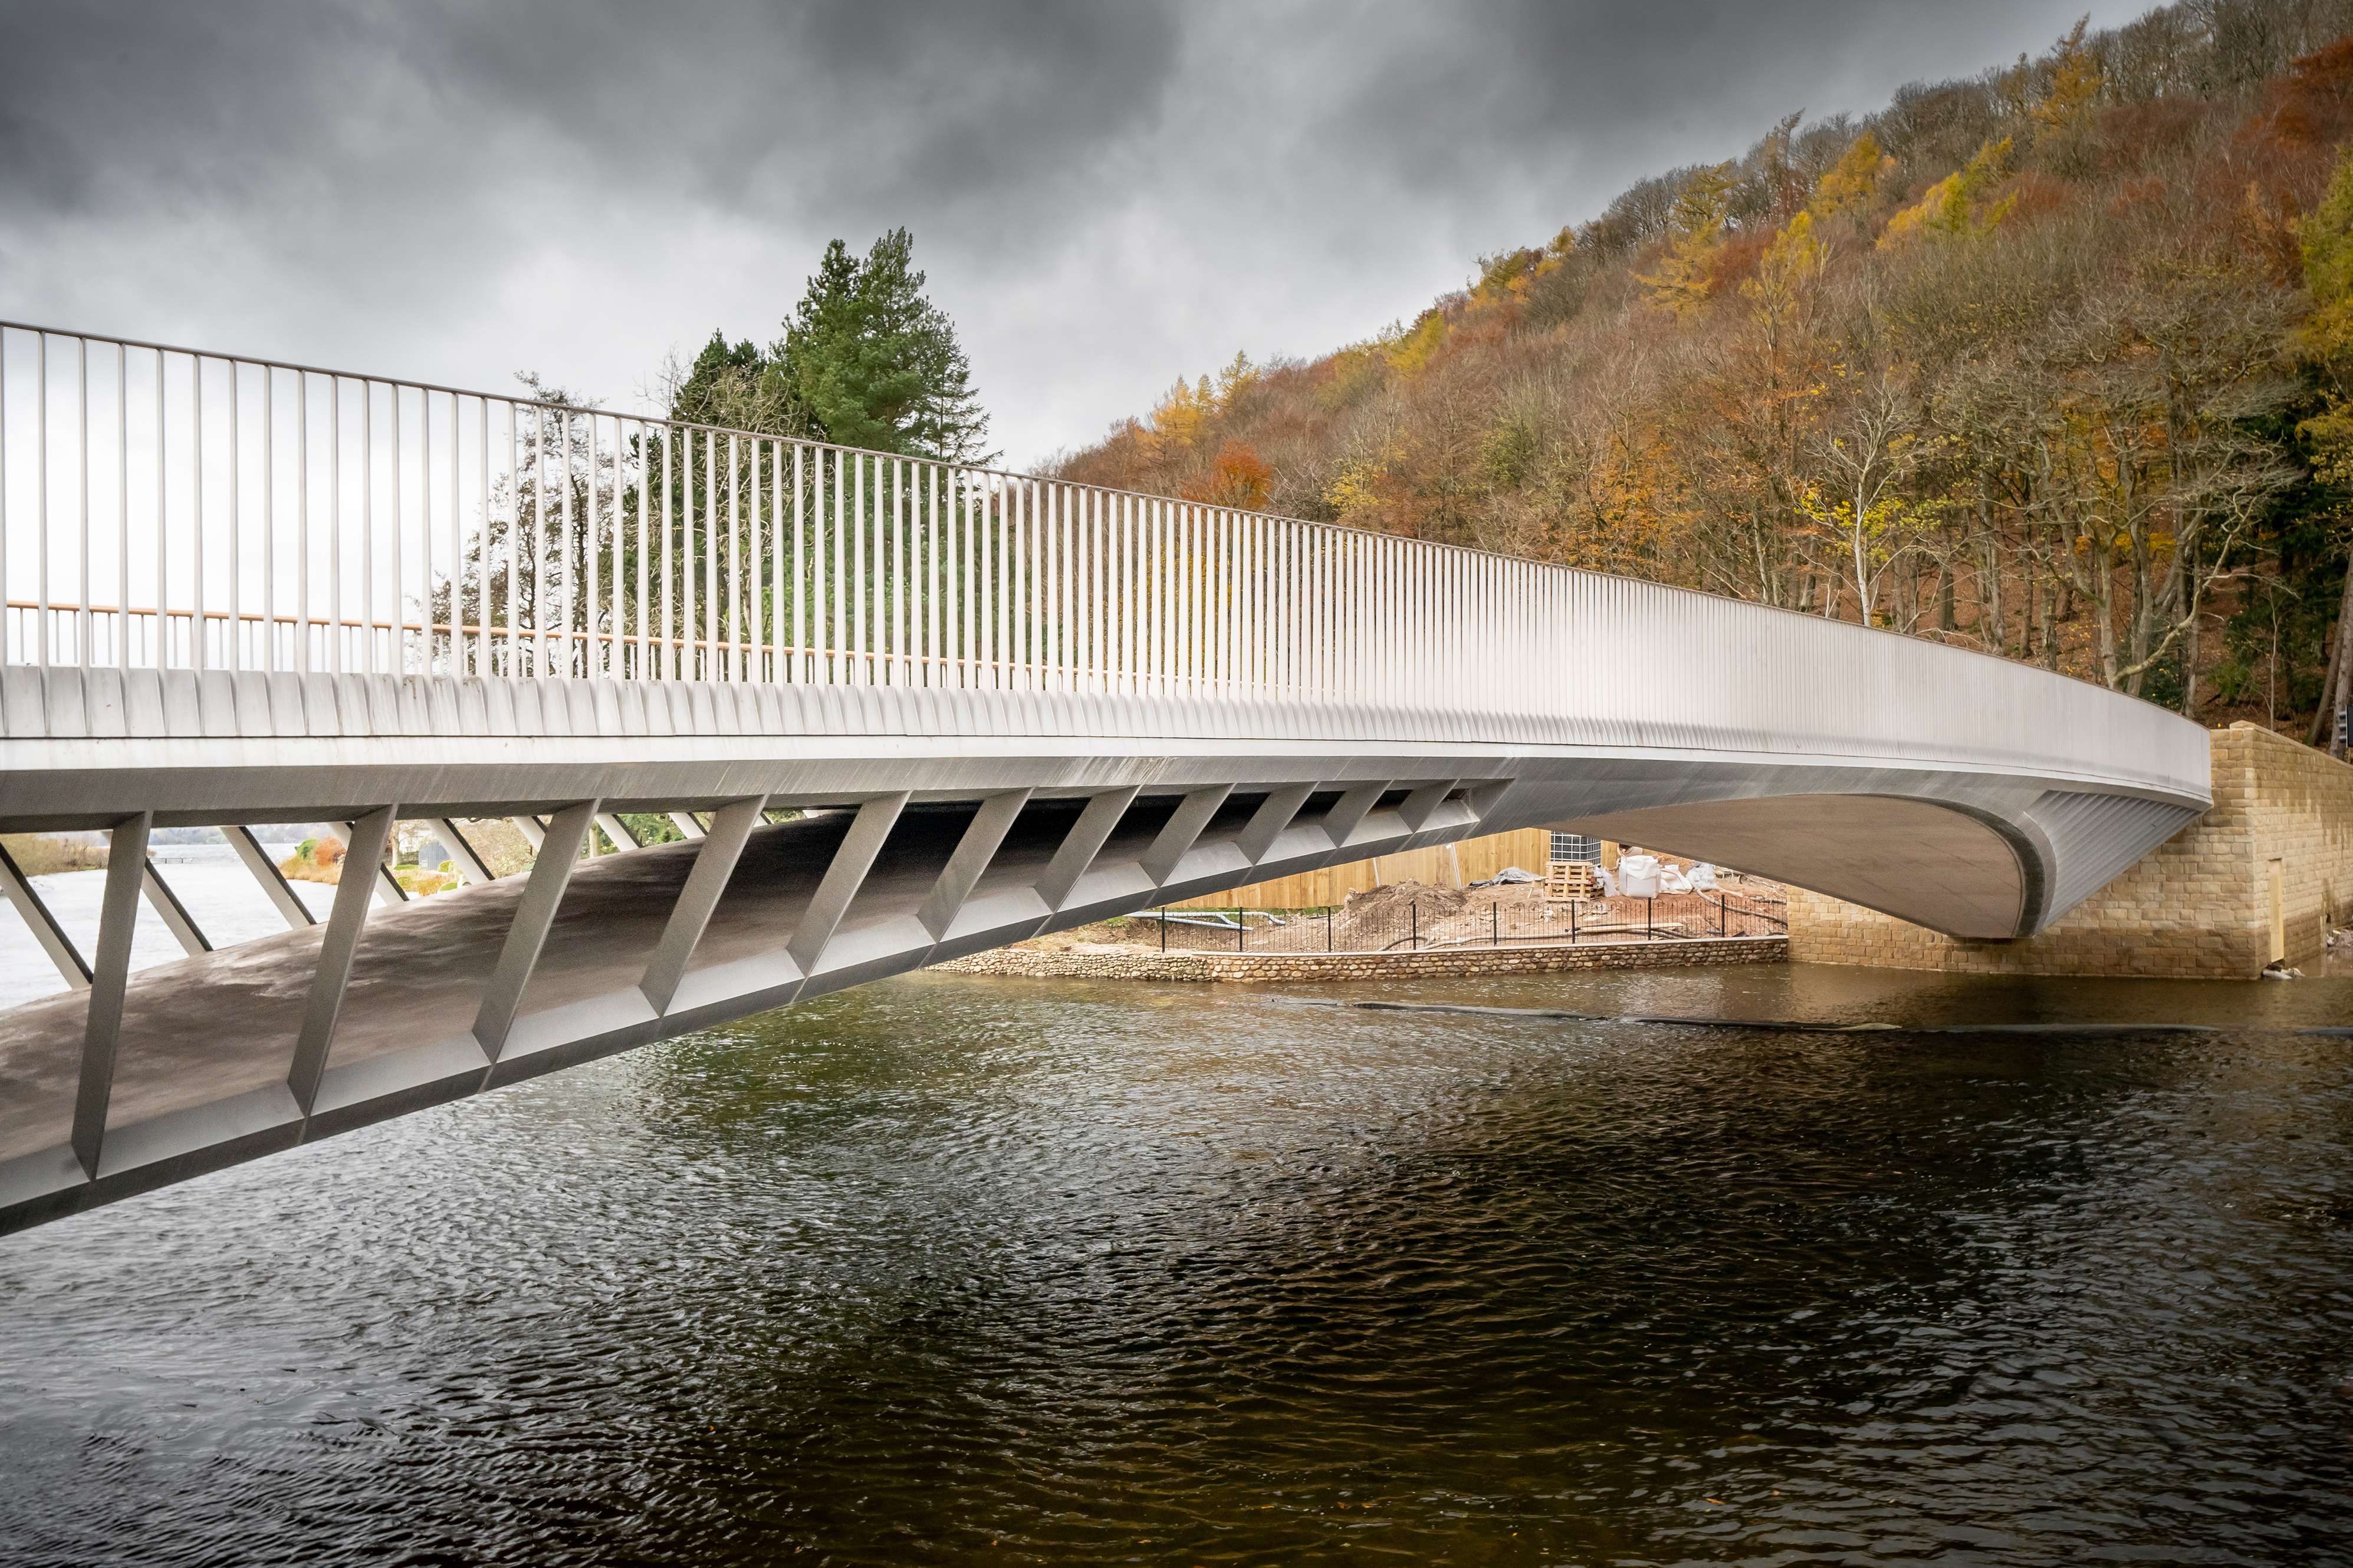
Image (c)Tom McNally

Please send your application by 16th October to:

Mike Bell, 52 South Park, Lytham, Lancs FY8 4QQ

Applications will be confirmed by email or post. Any queries to Mike on 01253 737580

BOOKING FORM OVERLEAF

BOOKING FORM
Please note we are transitioning to electronic banking and would prefer, if you can, bookings by email and payment by Bank Transfer. Cheques still acceptable!

Please reserve……...... places for the talk & lunch/talk only (please delete as applicable) on 23rd October 2025 - 10.30 for 11.00 a.m. at Crooklands Hotel.

The optional 3 course lunch is £30 per person. (The talk is free.)

I have paid ……. by (please delete option 1 or 2 below as applicable):

- BACS to Business Current Account: ‘Friends of IET Lancs & Cumbria’. Account number: 20812353; Sort code: 01-00-61; Reference – Your surname and date of event. I attach a receipt for my electronic payment.
or
- I enclose a cheque, payable to ‘Friends of the IET, Lancs & Cumbria’

Please give forenames and surnames of all those applied for, and any special dietary requirements.

Name(s)………………………………………………………………………………………………………………………………………………………………………………………………………………………………………………………………………………………………………………………………………………………...……………………………………………………………………………………….….

Contact Phone no...............................

Please give email address, or an address we can use to send confirmation of your booking.

…………………………………………………………………………………………………………….

Programme for remainder 2025

All meetings are 10.30 for 11.00am

4th December 2025 ‘Stars’ TBD, - Speaker TBD,
Netherwood Hotel, Grange-over-Sands

