





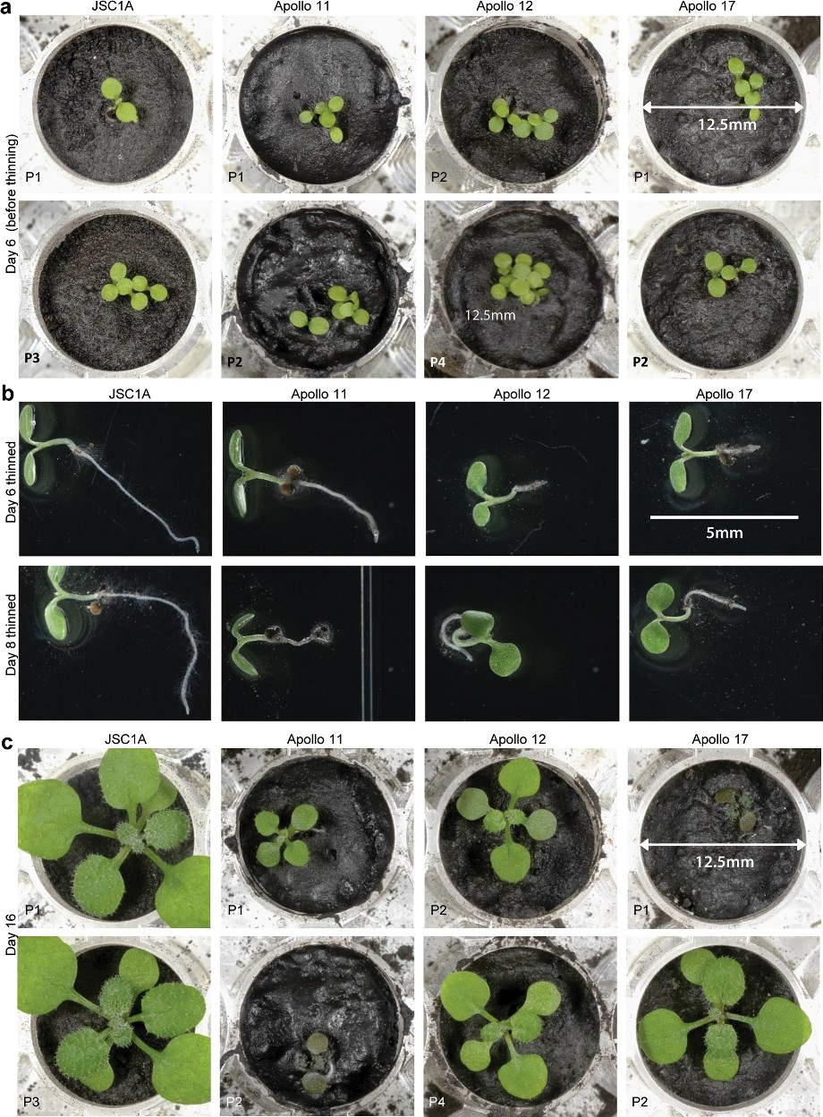

***For human space missions that extend beyond one or two years, resupply of large volumes and masses of food, water, and atmospheric gases becomes unrealistic. Therefore, long-duration future habitation of space will require bioregenerative life-support systems in which plants could play key roles, including atmosphere regeneration, wastewater recycling and food production. The use of in situ regolith as a seed germination and plant growth substrate may have several advantages over hydroponic systems, such as the immediate bioavailability of plant essential ions, low-tech mechanical support for plants, and easy access to in situ materials once on the surface. Since plants may play several key roles in long-term life support systems on the Moon or Mars, it is crucial to know how plant seeds should be stored and transported across space before being germinated and grown in such systems.***



**Arabidopsis plant growth in lunar regolith (Paul et al., 2022).**

**LIVING ON THE MOON, FARMING ON THE MOON**

**An illustrated lecture will be given by**

**Dr. Anne Visscher, Research Fellow, Royal Botanic Gardens, Kew, London. Lunaria One: Seed Biologist**

**as part of Plant Biology Team, Melbourne, Australia.**

**7.30pm, Wednesday 12th February 2025**

**FORUM, Duke Street, Barrow-in-Furness**

**This lecture qualifies for CPD accreditation**

**All Welcome Admission Free**

For further details contact Mr. I. Palmer Tel. 01229 832847

Or visit our website: [www.pesc.org.uk](http://www.pesc.org.uk)