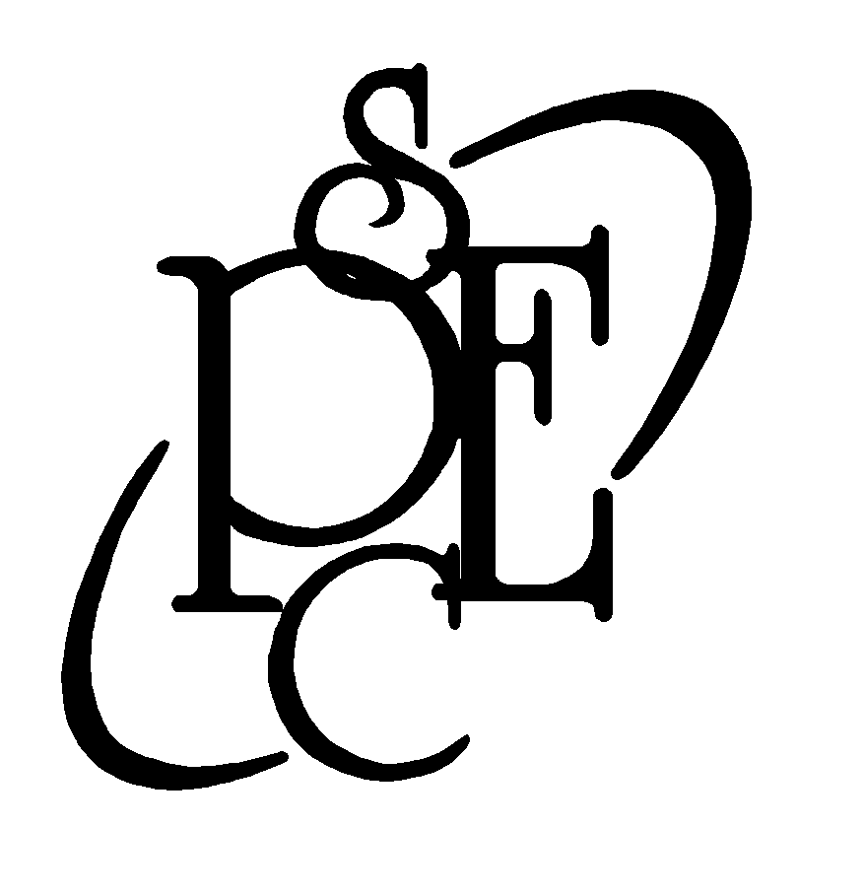
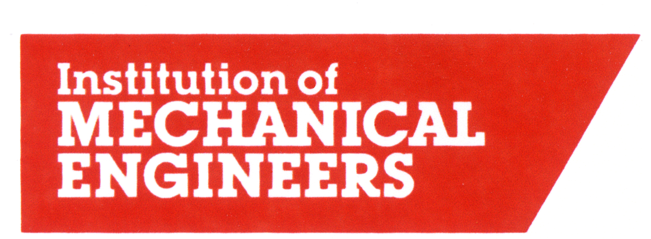


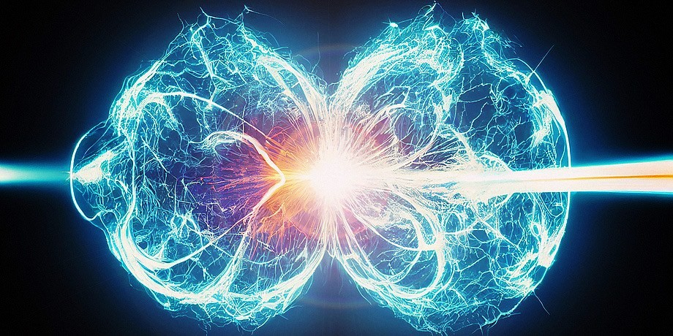

Nuclear fusion offers the possibility of long-term sustainable low-carbon energy, but some formidable technical challenges remain to be solved, including the fuel cycle. This talk will discuss the fuel used by fusion reactors and explore some of the challenges and potential solutions involved in providing a sustainable fusion fuel cycle.

‘THE CHALLENGES OF DEVELOPING A NUCLEAR FUSION FUEL CYCLE’
An illustrated lecture will be given by

Prof. Tim Abram, University of Manchester
Followed by IMechE AGM
7.30pm Wednesday 12th March 2025
THE FORUM, Duke Street, Barrow-in-Furness
This lecture qualifies for CPD accreditation
All Welcome Admission Free
For further details contact Mr. J.K. Higham Tel. 01229 831324
Or visit our website: www.pesc.org.uk

