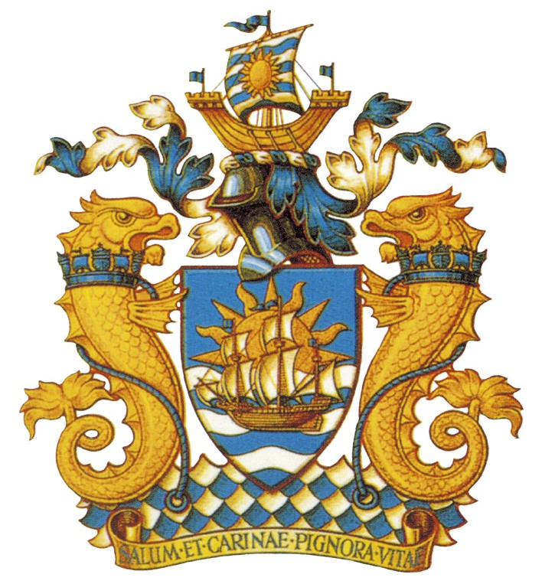
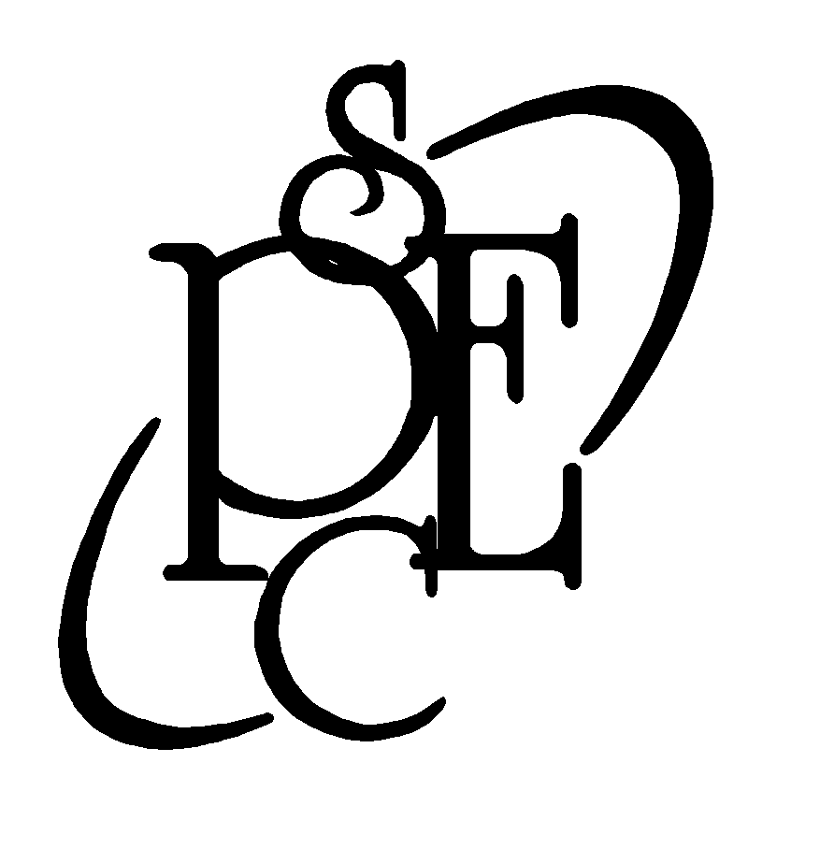
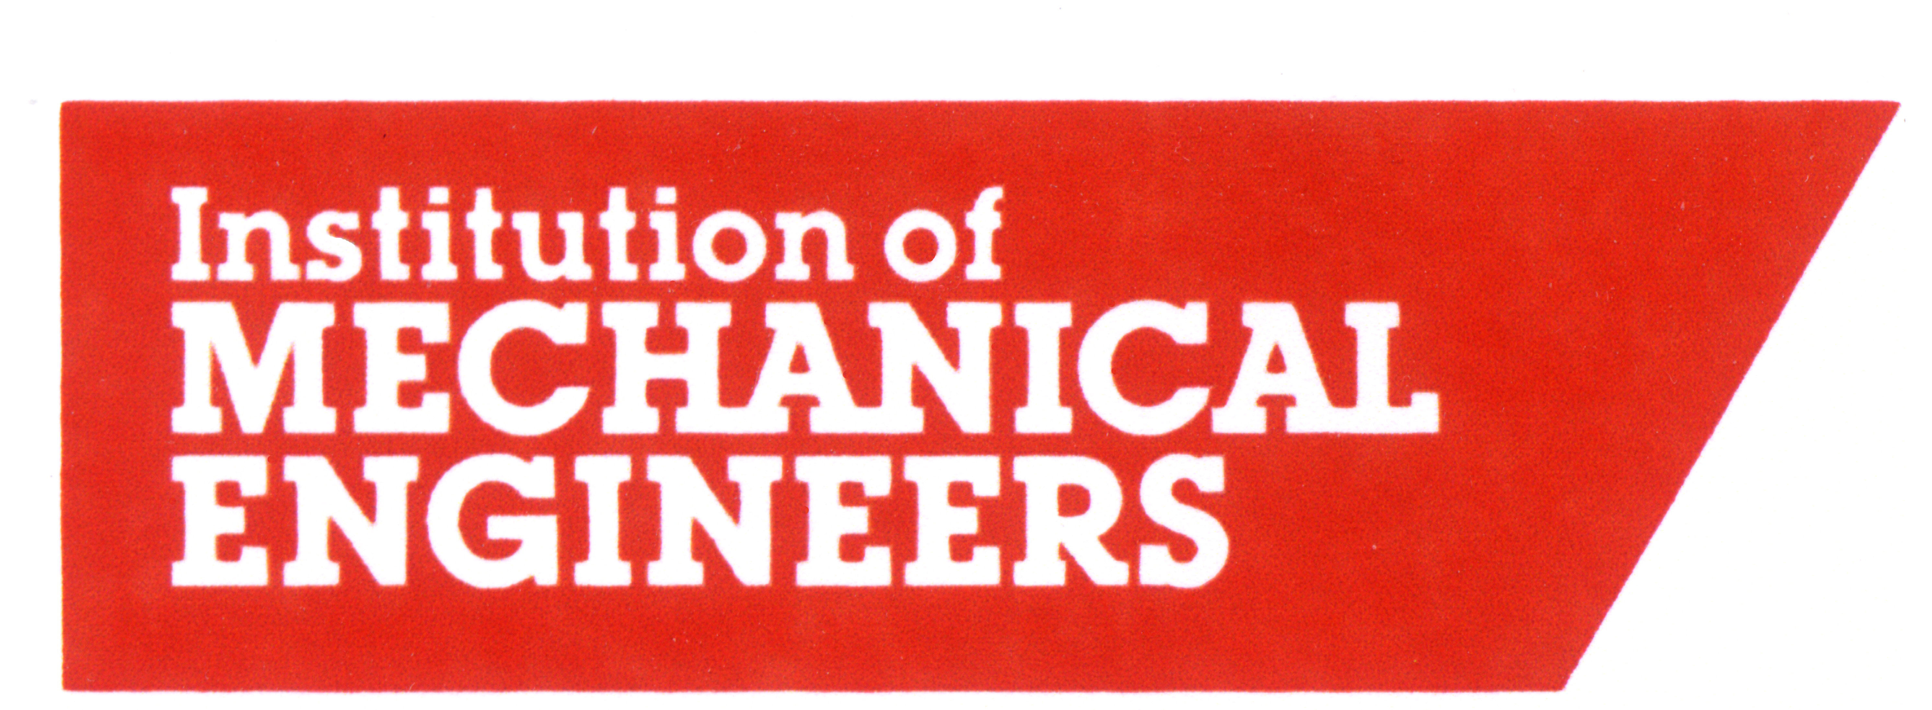



RINA
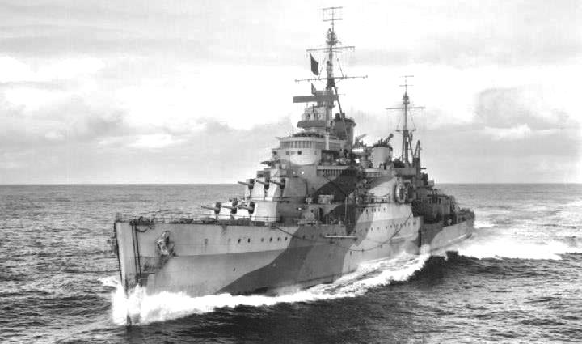

During the 1930s, with the London Naval Treaty of 1930 placing limitations on heavy cruiser warship construction and characteristics, the US, Japanese and British navies attempted to circumvent the restrictions on heavy cruiser construction by building light cruisers (vessels with an armament no heavier than 6.1in / 155mm) of similar size and fighting power to conventional heavy cruisers with 8in artillery. In Britain, this resulted first in the 10 Town class vessels, and latterly the reduced Fiji (aka Crown Colony) and Minotaur classes, built to fulfil the obligations of the Second London Naval Treaty of 1936.
Though largely overlooked, other than HMS Belfast for her role in the Battle of the North Cape, and her status as an IWM museum ship, the Towns, Fijis and first-completed Minotaurs played critical roles in the naval war 1939-'45, serving as fleet workhorses in all theatres of the conflict. This talk provides a short overview of these frequently-forgotten vessels and their operations during the conflict.

British Large Light Cruisers: The Town,
Fiji & Minotaur classes in action 1939-1945
An illustrated lecture will be given by
Dr. Scott M Lindgren, Naval Historian
7.30pm Wednesday 2nd April 2025
THE FORUM, Duke Street, Barrow-in-Furness
This lecture qualifies for CPD accreditation
All Welcome Admission Free
For further details, please contact Mr. J.K. Higham Tel. 01229 831324
Or visit our website: www.pesc.org.uk

